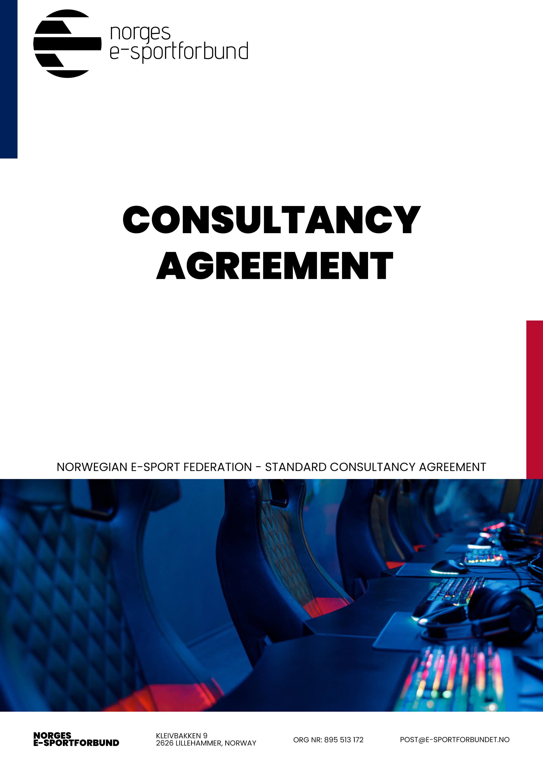

CONSULTANCY AGREEMENT
CLUB NAME, of ADDRESS, Norway with business reg. no. xxx xxx xxx (the «Club») and COMPANY NAME, of ADDRESS, Norway with business reg. no. xxx xxx xxx, for the services of PLAYER NAME (the «Consultant»), hereinafter collectively referred to as the «Parties», have on this date, DATE, entered into this consultancy agreement (the «Agreement»).

ENGAGEMENT
The Club hereby engages the Consultant to deliver professional services as an e-sports PLAYER/COACH for GAME exclusively to the Club («the Engagement»). The Engagement includes all services customarily provided with the role within professional e-sports, including but not limited to take part in the Club’s training, training camps, to represent the Club in any matches the Consultant is selected for during the Engagement Period, and to participate in the Club’s sponsor and marketing activities as detailed in item 3 below.
The Engagement starts at DATE and ends at DATE (the «Engagement Period»). The Agreement shall automatically expire at the end of the Engagement Period.
The Consultant agrees to always perform the Engagement in accordance with good standards for workmanship and in a diligent, timely, and competent manner.
The Consultant shall give written notice to the Club immediately if the Consultant experiences illnesses/injuries that affects or has the potential to impact the performance of the Engagement.

FEE, PRIZES AND EXPENSES
As consideration for the Engagement, the Club shall pay the Consultant a fixed amount of NOK AMOUNT,- excl. VAT (if applicable) per month / per match played (the «Fee»). The Fee is paid as a fixed amount on an «all-inclusive» basis. This means that the Fee includes all time and effort, preparations, social costs, insurance, as well as travel days, travel expenses etc.
The Fee is payable upon receipt of invoice from the Consultant, such invoice to be presented in accordance with approved accounting standards and due no earlier than 14 days from receipt.
The Fee is structured with the assumption that the Consultant will dedicate a minimum of 40 hours per week. Any additional time exceeding the above stipulations, will not result in supplementary compensation for the Consultant. If the Consultant is unable to fulfill the expected commitment, the Club has a right to adjust the Fee proportionally.
If the Club receives prize money for performances in a tournament, match or similar where the Consultant has represented the Club, the Consultant will receive xx % of the net sum received by the Club, unless otherwise follows from the tournament’s official revenue share scheme. Such prize moneys are due and payable after the Club has received the prize money (Club to inform Consultant) subject to the Club’s receipt of an accurate invoice from the Consultant.
If required pursuant to applicable taxing laws and regulations (including but not limited to the Foreign Artist Tax Act), the Club may deduct and report any applicable taxes from the Fee, price money or other payments to Contractor.
Reimbursement of expenses is subject to written approval by the Producer and appropriate documentation on a case- by- case basis.

MARKETING ACTIVITES, SPONSORSHIPS AND IMAGE RIGHTS
The Consultant shall contribute to the loyal fulfillment of all the Club’s obligations to its commercial partners as designated by the Club during the Engagement, and carry out marketing activities for the Club, including on their own social media and through streaming activities, all in accordance with the Club’s guidelines and instructions.
The Club shall continuously report to the Consultant which obligations the Club's commercial agreements impose on the Consultant.
Prior to entering into the Agreement, the Consultant must provide the Club with an overview of its own sponsorship agreements and all other commercial ties, as well as provide information on the main content of these so that the Club can assess whether there is a conflict with the Club's existing agreements.
The Club has the right to use, or to allow others to use, photographs and recordings of the Consultant during the Engagement Period, as well as the Consultant's name, gamertag/nickname and biography for any purpose, including in connection with marketing. For marketing material that has been delivered to the Club's partners, including sponsors, content producers, etc., this right shall last for the exploitation period that follows from the relevant agreement entered by the Club. After expiration of the Engagement Period, the Club's rights under this section are limited to photographs/recordings of the Consultant where the Consultant is not particularly highlighted or where events of historical importance to the Club are reproduced.

OTHER COMMITMENTS FOR THE CONSULTANT
The Consultant is obliged to be a member of the Club throughout the Engagement Period, and to act loyally towards the Club and always look after the Club's interests. This includes, inter alia, keeping the Club continuously informed on all matters of importance to the Club, Consultant's affiliation with the Club in all relevant activities, including using the Club's logo in relevant channels, and not mentioning the Club or the Club's partners negatively, including but not limited to social media, streaming etc.
The Consultant shall use the Club’s clothing and other effects that are made available to the Consultant by the Club when performing the Engagement, in accordance with the Club’s guidelines and instructions from time to time.
During the Engagement Period, the Consultant shall not:
- enter into personal sponsorship, ambassador or similar marketing agreements without the Club`s prior written consent;
- perform any tasks in connection with e-sports, including participating in matches, tournaments, events, streaming activities, etc., for third parties without the Club`s prior written consent.
The Consultant is obliged to comply with all applicable guidelines and instructions from the Club, relevant tournament rules, rules established by the Norwegian E-Sports Association or the rules applicable at any time to which members of the Norwegian E-Sports Association are subject, including applicable anti-doping codes.

OTHER COMMITMENTS FOR THE CLUB
The Club shall give prior notice to the Consultant about the activities the Consultant will participate in and not enter into any agreements that restrict the Consultant`s choice of competition equipment.

INDEPENDENT CONTRACTOR STATUS
The Parties agree that this Agreement creates an independent contractor relationship, not an employment relationship. The Consultant acknowledges and agrees that the Club will not provide the Consultant with any employee benefits, including without limitation any unemployment-, medical-, or pension payments, and that income tax withholding is the Consultant’s responsibility. In addition, the Parties acknowledge that neither party has, or shall be deemed to have, the authority to bind the other party and that nothing contained in this Agreement shall be deemed to constitute or create a partnership or joint venture between the Parties and neither Party shall hold itself out as the agent of the other.
The Consultant represents that he/she is sufficiently insured, and that the Consultant will be responsible for their own insurance coverage. The Club is therefore under no obligation to secure life, health, travel, accident, or any other insurance covering the Consultant.
If applicable for the Engagement, the Consultant warrants that the Consultant holds a valid passport, required permits and/or visas necessary to perform the Engagement, as well as a Covid-19 vaccine passport if required at the Consultant’s travel destinations.

NO ASSIGNMENT
This Agreement is personal, being entered into in reliance upon, and in consideration of, the skill and qualifications of the specific Consultant. The Consultant shall therefore not voluntarily or by operation of law assign or otherwise transfer the obligations incurred on its part pursuant to the terms of this Agreement without the Club’s prior written consent.

CANCELLATION
The Club may terminate this Agreement by written notice at any time. Upon termination by the Club, the Club shall pay the Consultant for services rendered up to such point of termination. The Club shall have no obligation to pay the Consultant any further compensation pursuant to this Agreement. The applicable portion of the Fee which has been paid or is payable for services already rendered as of the date of termination, shall constitute full payment by the Club for all services rendered and rights granted to the Club hereunder and shall be in full and final satisfaction of all claims, if any, that the Consultant may have against the Club in respect of this Agreement.

PERSONAL DATA
The Club will process the Consultant’s personal data for the purposes of entering into the Agreement, to comply with the Clubs legal obligations or to the extent that the Consultant has consented to the processing. General personal data may include but is not limited to, personal details, contact information, education, and professional expertise, etc. Personal data is primarily collected directly from the Consultant but may also stem from references or other third parties when needed. The reasons for processing personal data may include but is not limited to, administrative purposes, and transfer to third parties in and outside the EU/EEA-area for processing for the same purposes, and potentially also concerning due diligence-situations, restructuring and as part of legal processes. The Club will act in compliance with applicable laws and regulations governing the protection of personal data, such as GDPR. Further information about the Club`s processing of personal data may be obtained by contacting CONTACT INFO.

FORCE MAJEURE
Neither party shall be considered to be in default of the performance of its obligations under this Agreement, or be responsible for any delay in the carrying out of such obligations, if the performance thereof is prevented or delayed wholly or in part as a consequence whether direct or indirect of war (whether war be declared or not), riot, civil unrest, emergency, strike, earthquake, any act of God or any cause beyond the reasonable control of the party affected (force majeure). For the avoidance of doubt, payments to the Consultant will be suspended during such periods of force majeure where the Consultant is unable to perform its obligations under the Agreement.

CONFIDENTIALITY
The Consultant undertakes to maintain full confidentiality for all matters that the Consultant becomes aware of regarding the Club and the Club’s partners during the Engagement, including but not limited to the terms of this Agreement. This duty of confidentiality shall apply after the expiration of the Agreement, regardless of cause.

BREACH OF THE AGREEMENT
A breach occurs if the Consultant fails to perform in accordance with the functions, requirements etc., as agreed upon in this Agreement. The Contractor is obligated, if possible, to rectify any breaches without any claim for additional compensation. Failure to rectify a breach may result in liability for the costs incurred by the Club because of the breach.

DISPUTE RESOLUTION
Disputes regarding the Agreement shall primarily be resolved through negotiations between the Parties. The Agreement is governed by Norwegian law. All suits hereunder shall be brought before the ordinary courts at the Clubs registered place of business, and the Parties hereby submit to the exclusive jurisdiction thereof.

SIGNATURE
Digital/scanned signatures shall for all purposes be considered as original signatures.
***
PLACE, DATE
For CLUB NAME (the Club) | For COMPANY NAME (the Consultant)
_________________________ | _________________________
NAME | NAME

